Data Structure and Algorithm

Laboratory Activity No. 6

Singly Linked Lists

|  |  |
| --- | --- |
| *Submitted by:* | *Instructor:* |
| Balana,Jerkielle Roen O. | Engr. Maria Rizette H. Sayo |

August 23,2025

# Objectives

Introduction

A linked list is an organization of a list where each item in the list is in a separate node. Linked lists look like the links in a chain. Each link is attached to the next link by a reference that points to the next link in the chain. When working with a linked list, each link in the chain is called a Node. Each node consists of two pieces of information, an item, which is the data associated with the node, and a link to the next node in the linked list, often called next.

This laboratory activity aims to implement the principles and techniques in:

* Writing algorithms using Linked list
* Writing a python program that will perform the common operations in a singly linked list

# Methods

* Write a Python program to create a singly linked list of prime numbers less than 20. By iterating through the list, display all the prime numbers, the head, and the tail of the list. (using Google Colab)
* Save your source codes to GitHub

# Results

Present the visualized procedures done. Also present the results with corresponding data visualizations such as graphs, charts, tables, or image . Please provide insights, commentaries, or explanations regarding the data. If an explanation requires the support of literature such as academic journals, books, magazines, reports, or web articles please cite and reference them using the IEEE format.

Please take note of the styles on the style ribbon as these would serve as the style format of this laboratory report. The body style is Times New Roman size 12, line spacing: 1.5. Body text should be in Justified alignment, while captions should be center-aligned. Images should be readable and include captions. Please refer to the sample below:

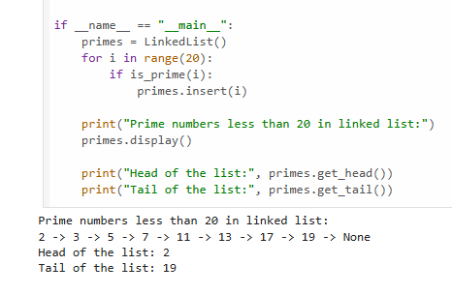

* The code that I created defines two classes, Node and LinkedList, to implement a linked list data structure. The Node class represents individual elements in the list, storing data and a reference to the next node. The LinkedList class manages the collection of nodes, providing methods for inserting new nodes, displaying the list's contents, and retrieving the head and tail nodes. Additionally, there is a function is_prime which determines if a given number is a prime number. The main section of the code initializes a LinkedList, populates it with prime numbers less than 20 using the is_prime function and the insert method, and then displays the resulting linked list and the values of its head and tail nodes.

Figure 1 & 2 Screenshot of program

If an image is taken from another literature or intellectual property, please cite them accordingly in the caption. Always keep in mind the Honor Code [1] of our course to prevent failure due to academic dishonesty.

# Conclusion

The conclusion expresses the summary of the whole laboratory report as perceived by the authors of the report.

The LinkedList class manages the collection of nodes, providing methods for inserting new nodes, displaying the list's contents, and retrieving the head and tail nodes. Additionally, there is a function is_prime which determines if a given number is a prime number. The main section of the code initializes a LinkedList, populates it with prime numbers less than 20 using the is_prime function and the insert method, and then displays the resulting linked list and the values of its head and tail nodes.

+

**References**

[1] Co Arthur O.. “University of Caloocan City Computer Engineering Department Honor Code,” UCC-CpE Departmental Policies, 2020.